2024-2025
Preschool Supply List
Yellow Room
4 and 5 year olds

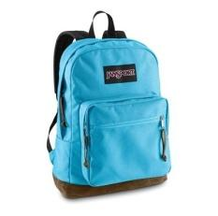  1 book bag. NO WHEELS. Needs to fit a binder/folder & at least one reusable lunch bag | 1 Reusable Lunch  bag/box for daily  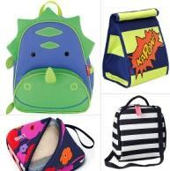  healthy snack and drink | 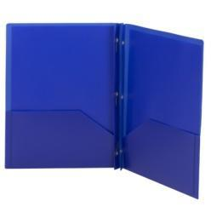  3-prong poly folder with pockets
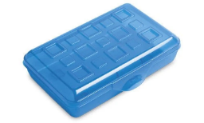  1 plastic supply box | 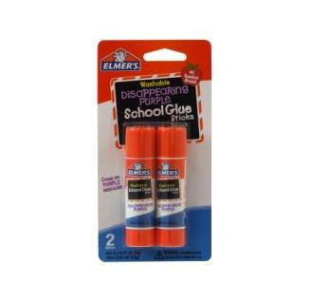  8 Elmer’s Glue Sticks | 1 pack “My First” Ticonderoga  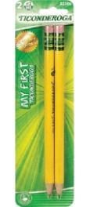  primary pencils
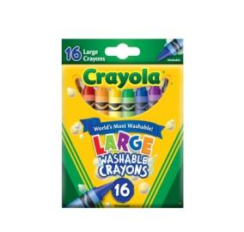  1 - 16 ct. Large Crayola Crayons | 1 - Crayola Watercolors  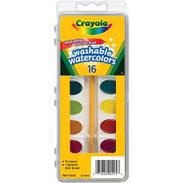 | 1 Kids Fiskar Scissors  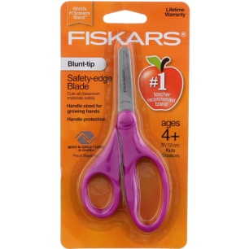
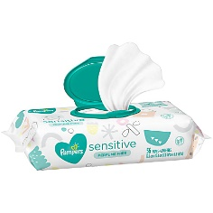  2 packs of baby wipes | 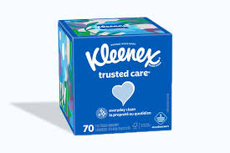  2 boxes of tissues | 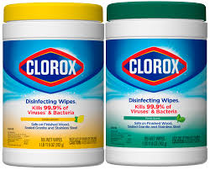  1 Clorox Wipe

*** We would also appreciate a donation of a 4-pack playdoh (any colors)
Mr. Clean magic erasers

